Lab 2.1 — Architecting Persona-Driven LLM Workflows

Table of Contents
Table of Contents 2
Introduction 3
Learning Objectives 3
Prerequisites 3
Part 1 — Initializing the Environment and Data Context 4
Step 1 — Connect the Session 4
Part 2 — Designing the System Prompts 5
Step 1 — Define the Persona Dictionary 5
Part 3 — Building the Dynamic Agentic Router 7
Step 1 — Create the Routing Function 7
Part 4 — Executing and Comparing Persona Outputs 9
Step 1 — Test the Executive Persona 9
Step 2 — Test the Analyst Persona 9
Knowledge Check 11
Clean Up 11
Troubleshooting 11
Symptom: SQL compilation error: syntax error line 1 at position... 11
Symptom: TypeError: complete() takes 2 positional arguments but X were given 12
Symptom: The Executive output is too long and ignoring the 3-bullet rule. 12
Conclusion 12

Introduction
Real-world AI applications fail when they provide a "one-size-fits-all" response. A C-Suite Executive requires high-level summaries, strategic impact statements, and brevity. Conversely, a Deep-dive Data Analyst requires raw metrics, methodological breakdowns, and actionable data structures (like JSON or SQL).
In this lab, you will build the backend routing logic for a persona-driven AI agent. Instead of writing monolithic prompts, you will utilize the conversational array capabilities of Snowflake Cortex. By dynamically injecting role-based "System Prompts" before passing the user's query to the LLM, you will force the model to adopt entirely different behaviors, output structures, and tones based on the assigned user persona. This foundational logic will power the interactive UI we build in the next lab.

Learning Objectives
Upon completing this lab, you will be able to:
- Construct conversational prompt arrays utilizing distinct system and user roles.
- Design robust System Prompts that dictate LLM tone, formatting, and structural output for specific organizational personas.
- Develop a dynamic Python routing function that orchestrates agentic workflows based on user state.
- Evaluate and compare the divergent outputs of the same underlying model when subjected to persona constraints.

Prerequisites
Before starting, ensure you have:
- Access to the Snowsight Web UI.
- Completed Lab 1.2 and have a functional Snowpark Container Services Notebook environment.
- The SNOWFLAKE.CORTEX_USER role granted to your execution context.

Part 1 — Initializing the Environment and Data Context
We will continue using the Snowpark Notebook environment to draft and test our Python logic before moving it to a production application.

Step 1 — Connect the Session
Open your existing Snowpark Notebook (or create a new one attached to a Compute Pool) and run the following initialization code in a Python cell to establish your context.
from snowflake.snowpark.context import get_active_session
from snowflake.cortex import complete

session = get_active_session()
session.use_database("ENTERPRISE_AI_SANDBOX")
session.use_schema("ANALYTICS")

Expected Output:
[No output expected. The cell will execute successfully and silently.]

Part 2 — Designing the System Prompts
The secret to agentic routing lies in the system prompt. This invisible set of instructions tells the LLM how to behave before it ever sees the user's question. We will define a dictionary containing strict instructions for two distinct personas.

Step 1 — Define the Persona Dictionary
Create a new Python cell and define the persona constraints. Notice how we explicitly restrict the Executive persona to markdown bullet points, while forcing the Analyst persona to provide structured, technical breakdowns.
persona_system_prompts = {
"Executive": """
You are a highly strategic AI Assistant reporting to the Chief Operating Officer.
Your goal is to provide maximum business value in the minimum amount of time.
Rules:
1. Never use technical jargon.
2. Keep your response to exactly 3 short bullet points.
3. Focus exclusively on ROI, risk, and high-level strategy.
4. Format as plain Markdown.
""",

"Analyst": """
You are an elite Senior Data Analyst AI.
Your goal is to provide deep technical insights, raw metrics, and structural methodologies.
Rules:
1. Always explain the 'why' and the 'how'.
2. Break down the data logically.
3. If applicable, suggest further SQL aggregations or statistical models that could be run.
4. Use detailed technical language.
"""
}
print(f"Loaded definitions for: {list(persona_system_prompts.keys())}")

Expected Output:
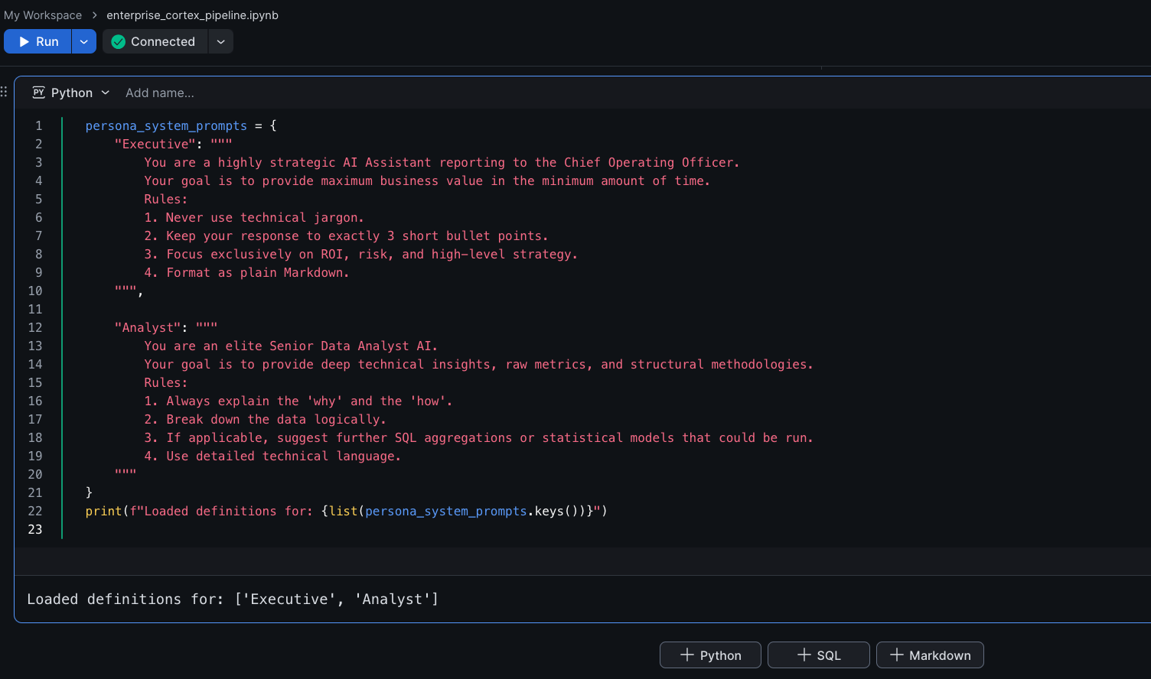

Part 3 — Building the Dynamic Agentic Router
To ensure maximum compatibility and bypass potential REST API network restrictions, we will construct our prompt programmatically in Python, and then use the Snowpark session.sql() method to execute the Cortex inference directly via the Snowflake SQL engine.

Step 1 — Create the Routing Function
We will write a Python function that takes a user query and a persona string, formats them into a single comprehensive prompt, escapes necessary characters, and invokes the SNOWFLAKE.CORTEX.COMPLETE SQL function.
def ask_ai_agent(user_query: str, persona: str) -> str:
if persona not in persona_system_prompts:
raise ValueError("Invalid Persona selected.")

prompt = f"""[SYSTEM]: {persona_system_prompts[persona]}

[USER]: {user_query}"""

escaped_prompt = prompt.replace("'", "''")
result = session.sql(f"SELECT SNOWFLAKE.CORTEX.COMPLETE('llama3.1-8b', '{escaped_prompt}') AS response").collect()
return result[0]['RESPONSE']

print("Agentic Router function initialized.")

Expected Output:
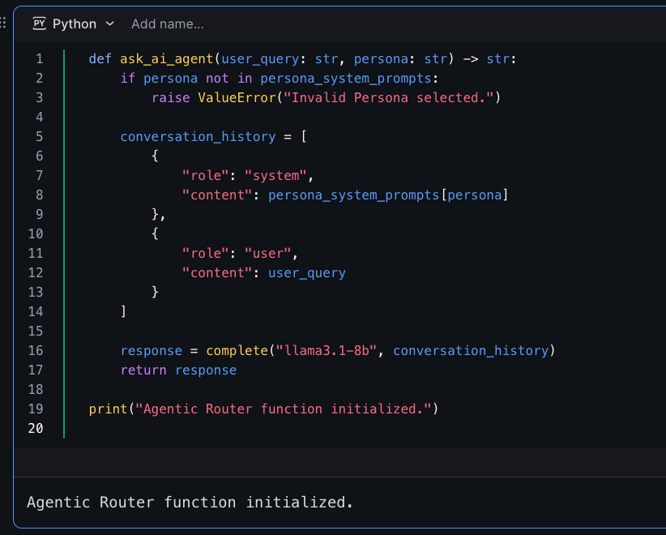

Part 4 — Executing and Comparing Persona Outputs
Let's test our router by asking both personas the exact same question regarding a hypothetical enterprise event data anomaly.

Step 1 — Test the Executive Persona
Execute the function simulating an Executive user asking about a spike in negative feedback.
business_question = "We saw a 40% drop in NPS scores at yesterday's tech summit compared to last year. Why did this happen and what should we do?"

executive_response = ask_ai_agent(business_question, "Executive")

print("--- EXECUTIVE VIEW ---")
print(executive_response)

Expected Output:
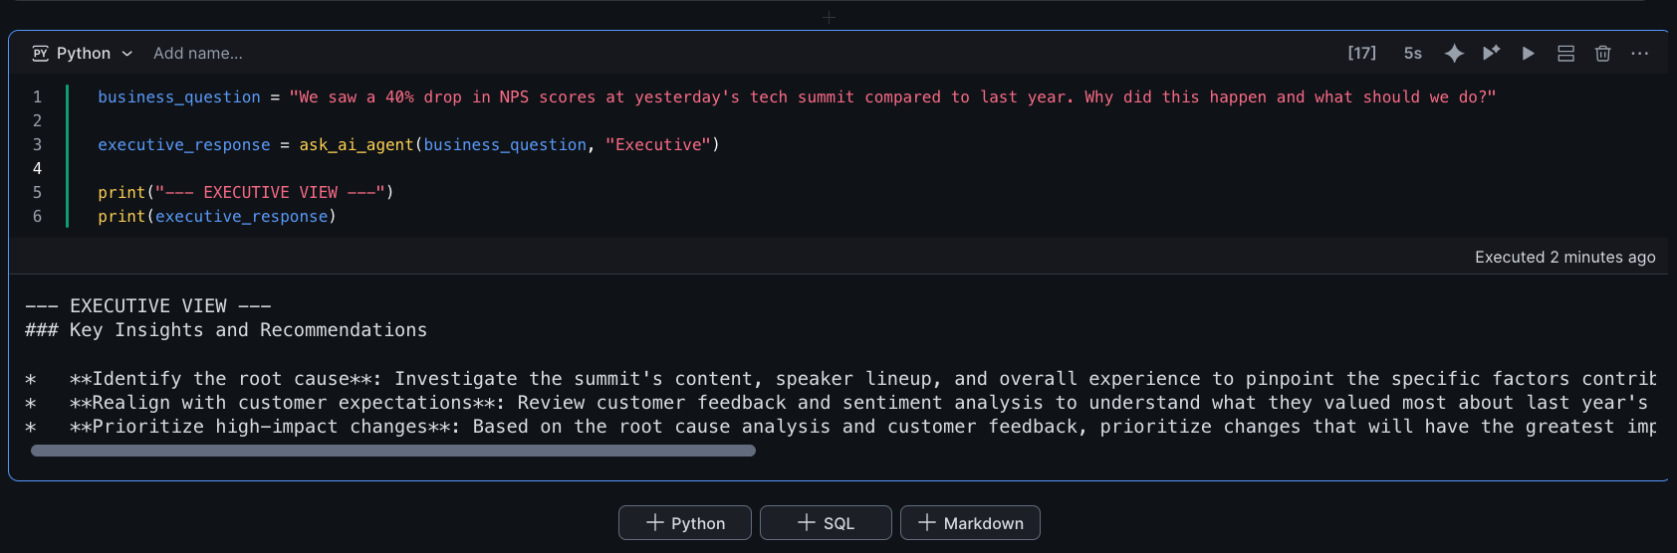

Step 2 — Test the Analyst Persona
Now, ask the exact same question, but route it through the Analyst persona.
analyst_response = ask_ai_agent(business_question, "Analyst")

print("--- ANALYST VIEW ---")
print(analyst_response)

Expected Output:
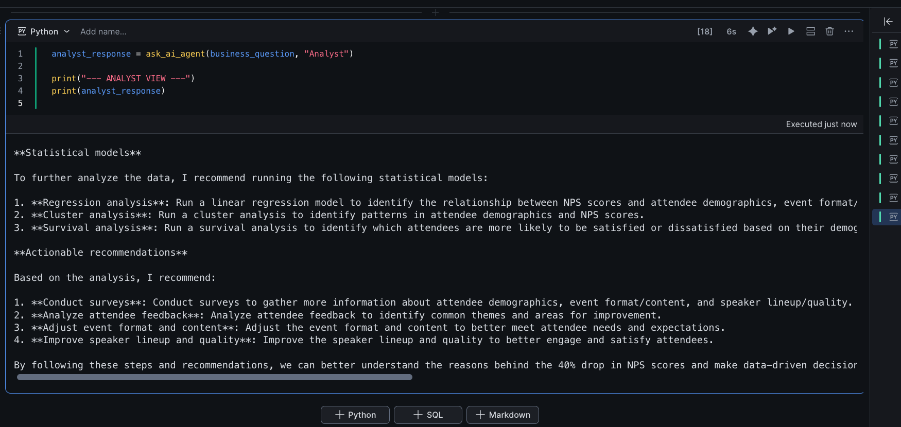

Knowledge Check
- In the Cortex complete function, what is the fundamental difference between the system role and the user role within the conversational array?
  - Answer: The user role represents the human's input or question. The system role represents the invisible developer instructions that constrain and govern how the LLM processes that user input, allowing you to set distinct behaviors (like personas) without the user seeing the instructions.
- Why is building a dynamic routing function in Python better than forcing the user to type "Summarize this like an executive: [Question]" every time?
  - Answer: It abstracts the prompt engineering away from the end user, ensuring consistent, standardized outputs across the enterprise and enabling seamless frontend UI toggles rather than relying on human prompt-writing skills.
- Why did we format the prompt with explicit [SYSTEM]: and [USER]: tags before passing it to the SQL engine?
- Answer: When passing a single string to a Large Language Model, tagging the sections helps the model differentiate between developer instructions (System) and the actual human query (User), mimicking the behavior of a structured conversational array.

Clean Up
This lab focused on memory-based function definitions. Ensure your notebook is saved. If you are finished for the day, safely shut down your compute kernel to prevent idle resource consumption.
- Click the Connect dropdown at the top of your notebook.
- Select Shut down kernel.

Troubleshooting

Symptom: SQL compilation error: syntax error line 1 at position...
Solution: This usually happens if there are unescaped single quotes (') in your user query that break the generated SQL string. Ensure the prompt.replace("'", "''") logic is correctly applied before passing the prompt to session.sql().

Symptom: TypeError: complete() takes 2 positional arguments but X were given
Solution: Ensure you are passing the conversation_history as a single list containing dictionaries, not as multiple separate string arguments. The signature expects complete("model_name", [{"role": "...", "content": "..."}]).

Symptom: The Executive output is too long and ignoring the 3-bullet rule.
Solution: Smaller LLMs (like an 8b model) occasionally lose adherence to strict systemic constraints if the user query is overwhelmingly complex. If you experience drift, upgrade the model string in the ask_ai_agent function from llama3.1-8b to a larger parameter model available in your region, such as llama3.1-70b.

Conclusion
In this lab, you successfully built the backend architecture for a persona-driven AI application. By separating your instructions into dynamic system prompts and combining them with the user prompt inside a conversational array, you engineered an AI agent that drastically alters its UX output based on state parameters. You are now ready to wrap this logic into an interactive, front-end application using Streamlit in Snowflake.

